Terraform-06
1). Watch the Terraform-06 video.
✅ Completed — Watched the Terraform-06 video.
2). Execute the script shown in the video.
What the document means by Modules
The document explains that a module is a reusable collection of Terraform configuration files. Instead of duplicating EC2 code for Development, Production, Testing, etc., we create the infrastructure logic once and reuse it.
The screenshot specifically shows a production environment calling an EC2 module.
So we will use this structure:
Terraform-Modules/
│
├── aws_instance/
│ ├── main.tf
│ └── variables.tf
│
└── production/
├── main.tf
└── variables.tf
This is much closer to the structure shown in your screenshots.

STEP 1 — Create the main folder
In:
D:\Terraform
create:
Terraform-Modules-Screenshot
Open it in VS Code.

STEP 2 — Create the module folder
Inside:
Terraform-Modules-Screenshot
create:
aws_instance
Then create another folder:
production
Final structure:
Terraform-Modules-Screenshot/
│
├── aws_instance/
│
└── production/

STEP 3 — Create module files
Inside:
aws_instance
create:
main.tf
variables.tf
So:
aws_instance/
├── main.tf
└── variables.tf

STEP 4 — Write the reusable EC2 module
Open:
aws_instance/main.tf
Use:
resource "aws_instance" "webserver" {
ami = var.ami
instance_type = var.instance_type

tags = {
Name = var.instance_name
}
}
This is our reusable EC2 module.

STEP 5 — Create module variables
Open:
aws_instance/variables.tf
Put:
variable "ami" {
type = string
}

variable "instance_type" {
type = string
}

variable "instance_name" {
type = string
}
Now the module can receive different values.
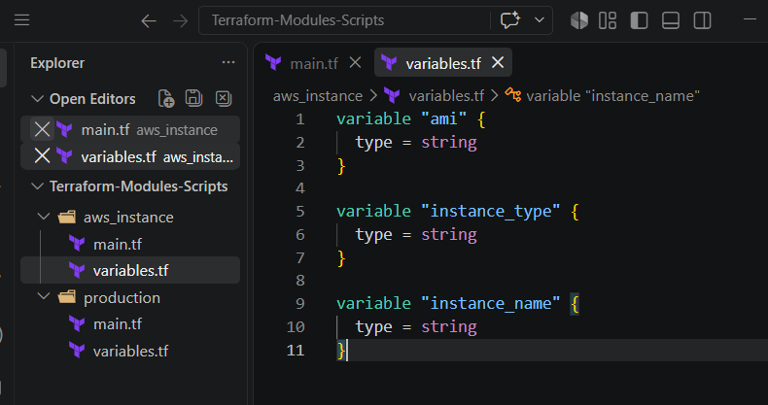

STEP 6 — Create Production files
Inside:
production
create:
main.tf
variables.tf
Structure:
production/
├── main.tf
└── variables.tf
The document specifically says to go to the production environment and write Terraform code in main.tf containing a module block.

STEP 7 — Create Production main.tf
Open:
production/main.tf
Put:
terraform {
required_providers {
aws = {
source = "hashicorp/aws"
version = "~> 6.0"
}
}
}

provider "aws" {
region = var.aws_region
}

module "dev-webserver" {
source = "../aws_instance"

ami = var.ami
instance_type = var.instance_type
instance_name = var.instance_name
}
Important
This line is the key:
source = "../aws_instance"
It tells Terraform:
"Use the reusable module located one directory above me."
This matches the module structure shown in the screenshot, where the production configuration calls the dev-webserver module.

STEP 8 — Create Production variables
Open:
production/variables.tf
Put:
variable "aws_region" {
type = string
default = "ap-south-1"
}

variable "ami" {
type = string
}

variable "instance_type" {
type = string
default = "t3.micro"
}

variable "instance_name" {
type = string
default = "terraform-module-webserver"
}
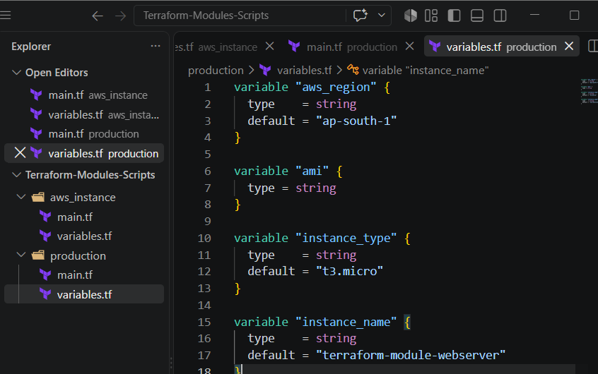

STEP 9 — Final structure
You should now have:
Terraform-Modules-Screenshot/
│
├── aws_instance/
│ ├── main.tf
│ └── variables.tf
│
└── production/
├── main.tf
└── variables.tf
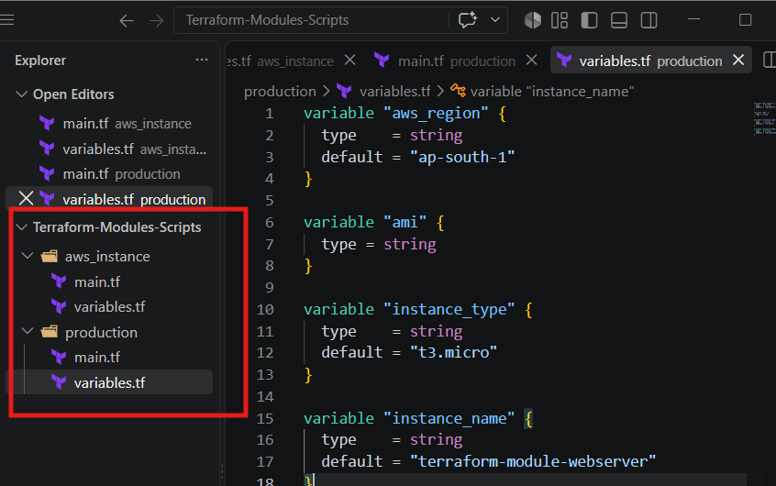
Architecture
production/
│
│ module "dev-webserver"
│ source = "../aws_instance"
↓
aws_instance/
│
└── aws_instance.webserver
│
↓
AWS EC2
This is the important concept demonstrated in your document.

STEP 10 — Go to Production directory
This is important.
Your screenshot shows the Terraform commands being run from the production directory.
In VS Code terminal:
cd /d/Terraform/Terraform-Modules-Screenshot/production
Verify:
pwd
You should see:
/d/Terraform/Terraform-Modules-Screenshot/production
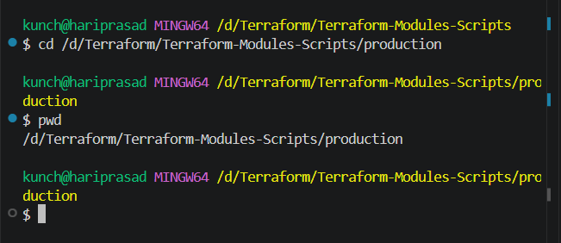
STEP 11 — Terraform Init
The document's screenshot shows:
terraform init
being executed from the production directory.
Run:
terraform init
Terraform will initialize:
Backend
Modules
Provider
You should eventually see:
Terraform has been successfully initialized!
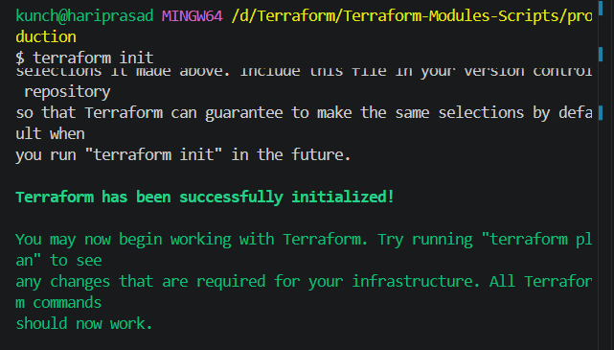

STEP 12 — Terraform Validate
The next command in your screenshot is:
terraform validate
Run:
terraform validate
Expected:
Success! The configuration is valid.
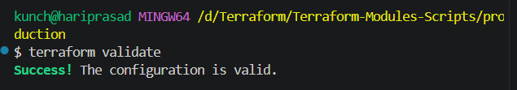

STEP 13 — Terraform Plan
Now run:
terraform plan -var="ami=ami-08188a5a4dfdbd573"
You should see something similar to the screenshot:
Terraform will perform the following actions:

# module.dev-webserver.aws_instance.webserver will be created
And finally:
Plan: 1 to add, 0 to change, 0 to destroy.
The document's screenshot shows exactly this module resource pattern.
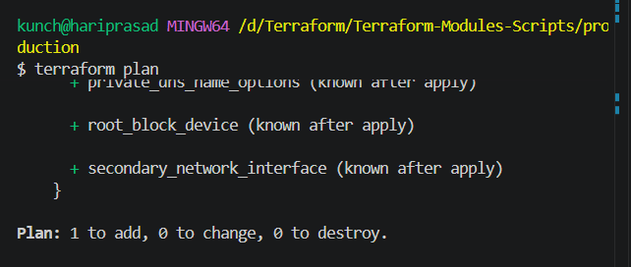

STEP 14 — Terraform Apply
Now:
terraform apply -var="ami=ami-08188a5a4dfdbd573"
Terraform will ask:
Do you want to perform these actions?
Enter:
yes
You should eventually see:
Apply complete! Resources: 1 added, 0 changed, 0 destroyed.
This matches the apply workflow shown on page 4.
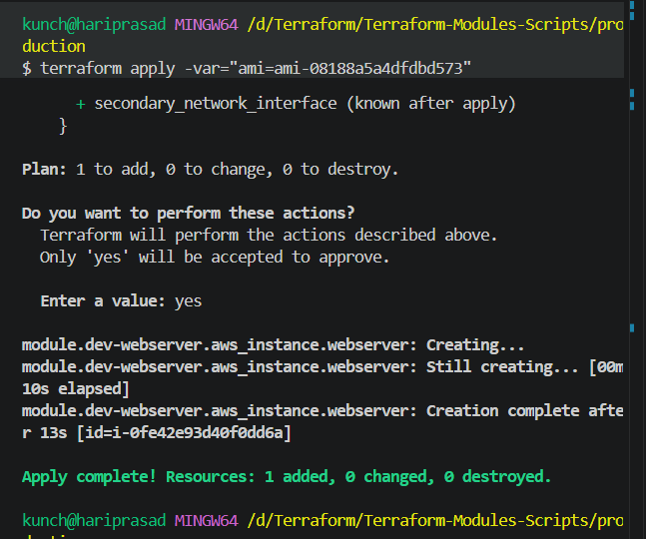

STEP 15 — Check AWS Console
Now go to:
AWS Console → EC2 → Instances
You should see:
terraform-module-webserver
with:
Instance type: t3.micro
State: Running
The document specifically instructs you to go to the AWS console and check the instance after terraform apply.
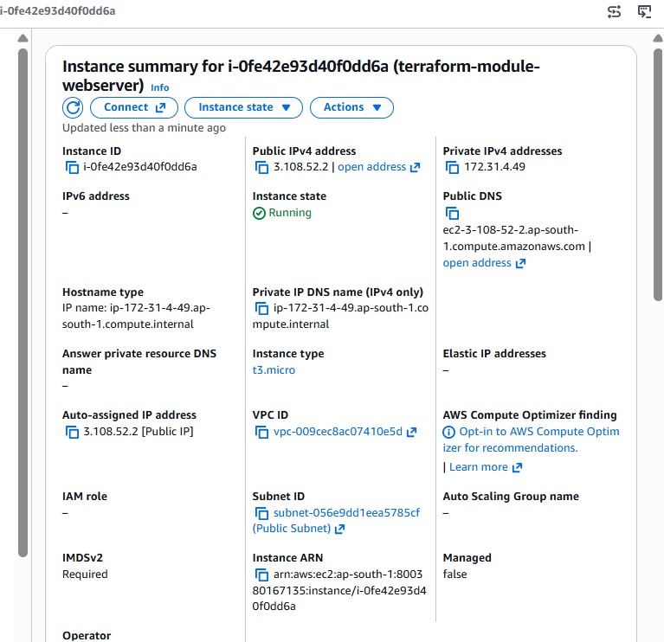

STEP 16 — Verify the module in Terraform
From:
production
run:
terraform state list
You should see:
module.dev-webserver.aws_instance.webserver
This is important because it proves that the EC2 was created through the module.
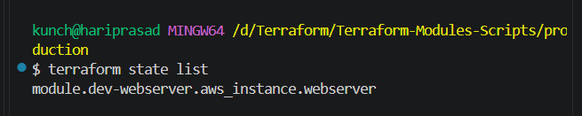

STEP 17 — Clean up
After verifying the EC2:
terraform destroy -var="ami=ami-08188a5a4dfdbd573"
Enter:
yes
Then:
terraform state list
It should be empty.

✅ Task 3 — Screenshot-based procedure completed
Your flow now matches the document:
Create reusable module
↓
Production environment
↓
Module block
↓
terraform init
↓
terraform validate
↓
terraform plan
↓
terraform apply
↓
AWS Console
↓
Verify EC2
↓
terraform destroy

Terraform Workspaces
Step 1 — Create a NEW project
Do not use your Terraform-Modules project.
Create:
D:\Terraform\Terraform-Workspaces
Open this folder in VS Code.

Step 2 — Create Terraform files
Inside Terraform-Workspaces, create:
Terraform-Workspaces/
│
├── main.tf
└── variables.tf
The important point is that we use the same main.tf for all environments.

Step 3 — Create main.tf
Open:
main.tf
Use:
terraform {
required_providers {
aws = {
source = "hashicorp/aws"
version = "~> 6.0"
}
}
}

provider "aws" {
region = "ap-south-1"
}

resource "aws_instance" "webserver" {
ami = var.ami
instance_type = "t3.micro"

tags = {
Name = "terraform-${terraform.workspace}"
Environment = terraform.workspace
}
}
Important part
terraform.workspace
This automatically identifies the workspace.
For example:
dev → terraform.workspace = dev
staging → terraform.workspace = staging
prod → terraform.workspace = prod
So the same code creates:
terraform-dev
terraform-staging
terraform-prod

Step 4 — Create variables.tf
Open:
variables.tf
Put:
variable "ami" {
type = string
}

Step 5 — Initialize Terraform
Open the terminal in:
D:\Terraform\Terraform-Workspaces
Run:
terraform init
Your document specifically shows Terraform init as part of running Terraform.
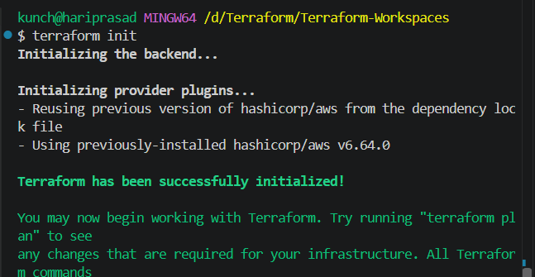
Then:
terraform validate
Expected:
Success! The configuration is valid.
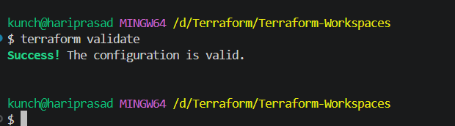

Step 6 — Check current workspace
The document's first workspace command is:
terraform workspace show
Run:
terraform workspace show
Initially:
Default
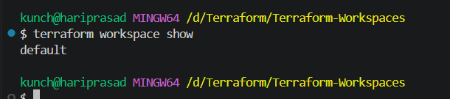

Step 7 — List workspaces
Run:
terraform workspace list
You should initially see:
* default
This is the second workspace command shown in your document.
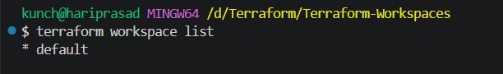

Step 8 — Create Dev workspace
Run:
terraform workspace new dev
The document uses:
terraform workspace new workspacename
for creating a workspace.
You should see:
Created and switched to workspace "dev"!
Check:
terraform workspace show
Output:
Dev
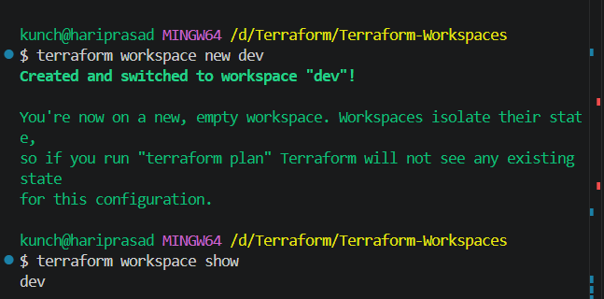

Step 9 — Run Terraform plan for Dev
Use the same AMI you have already been using:
terraform plan -var="ami=ami-08188a5a4dfdbd573"
You should see:
Plan: 1 to add, 0 to change, 0 to destroy.
And the EC2 name should be:
terraform-dev
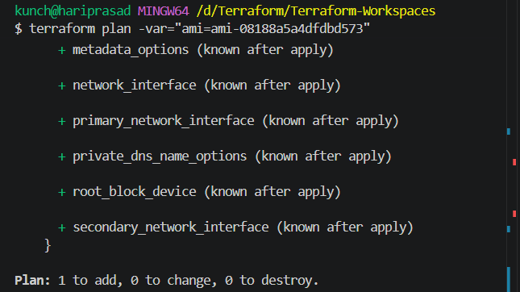

Step 10 — Apply Dev
Run:
terraform apply -var="ami=ami-08188a5a4dfdbd573"
Enter:
yes
Expected:
Apply complete! Resources: 1 added, 0 changed, 0 destroyed.
Check AWS EC2.
You should have:
Name: terraform-dev
Type: t3.micro
The document's workflow also shows terraform apply followed by checking the EC2 instance in the AWS Console.
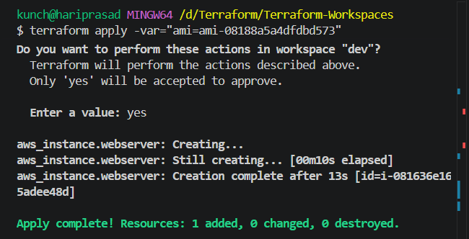

Step 11 — Create Staging workspace
Now use the same Terraform code.
Create:
terraform workspace new staging
Check:
terraform workspace show
Expected:
staging
List:
terraform workspace list
You should see:
default
dev
* staging
The * indicates the currently selected workspace.
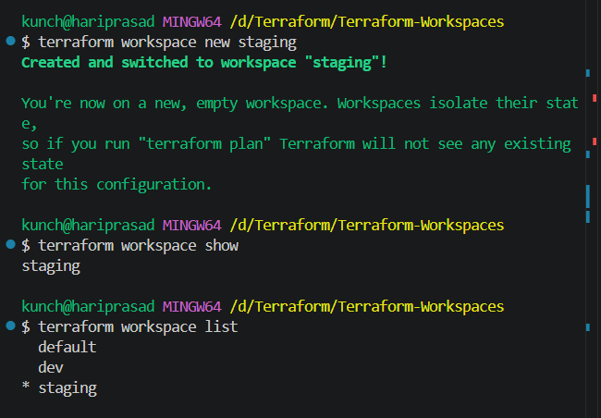

Step 12 — Apply Staging
Run:
terraform plan -var="ami=ami-08188a5a4dfdbd573"
Then:
terraform apply -var="ami=ami-08188a5a4dfdbd573"
Enter:
yes
Because we're in staging, the same code creates:
Name = terraform-staging
Now AWS should have:
terraform-dev
terraform-staging
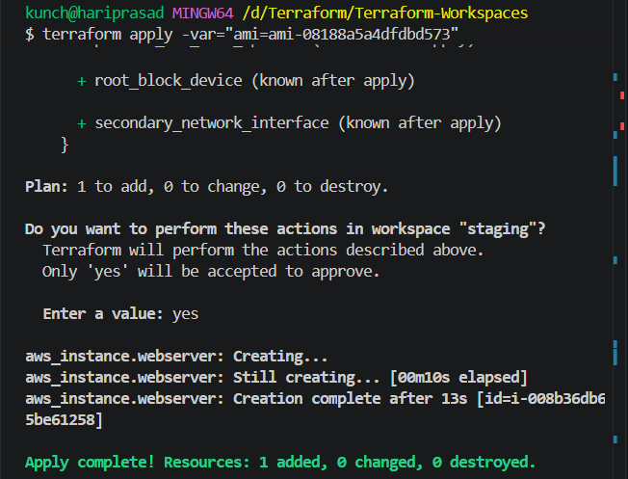

Step 13 — Create Prod workspace
Run:
terraform workspace new prod
Check:
terraform workspace show
Expected:
prod
Then:
terraform workspace list
You should see:
default
dev
staging
* prod
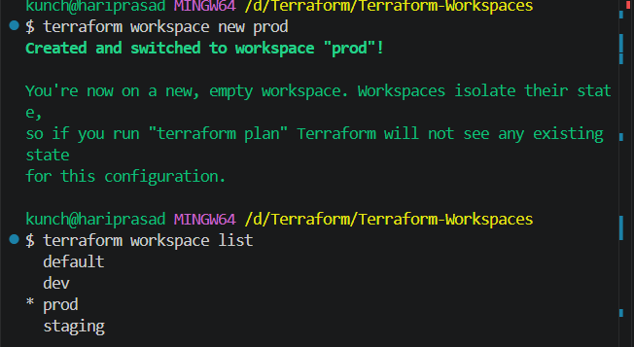

Step 14 — Apply Prod
Run:
terraform plan -var="ami=ami-08188a5a4dfdbd573"
Then:
terraform apply -var="ami=ami-08188a5a4dfdbd573"
Enter:
yes
Now you should have:
terraform-dev
terraform-staging
terraform-prod
All are created from the same main.tf.
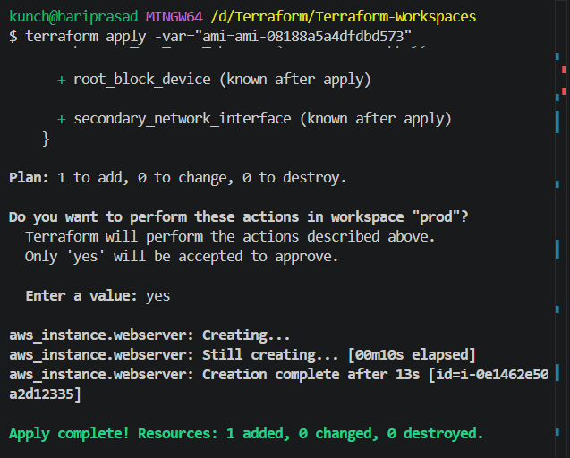

Step 15 — Demonstrate separate state
This is the most important part of the exercise.
The document explains that each workspace has its own state, conceptually:
terraform.tfstate.d/
│
├── dev/
│ └── terraform.tfstate
│
├── test/
│ └── terraform.tfstate
│
└── prod/
└── terraform.tfstate
So an EC2 tracked in dev is separate from the EC2 tracked in prod.
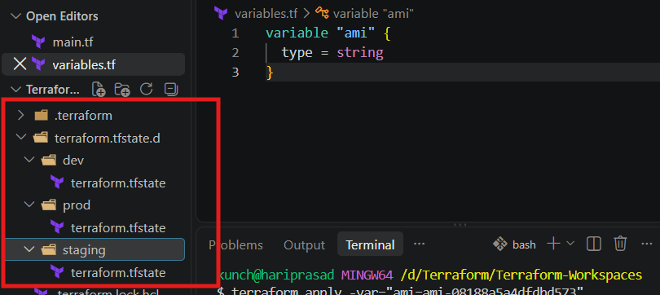
You can demonstrate this.
Select Dev
terraform workspace select dev
Then:
terraform state list
You should see:
aws_instance.webserver
Now select Staging:
terraform workspace select staging
Run:
terraform state list
Again:
aws_instance.webserver
It has the same resource address, but it belongs to a different workspace state.
Then Prod:
terraform workspace select prod
terraform state list
Again:
aws_instance.webserver
That's the core concept of Terraform Workspaces.
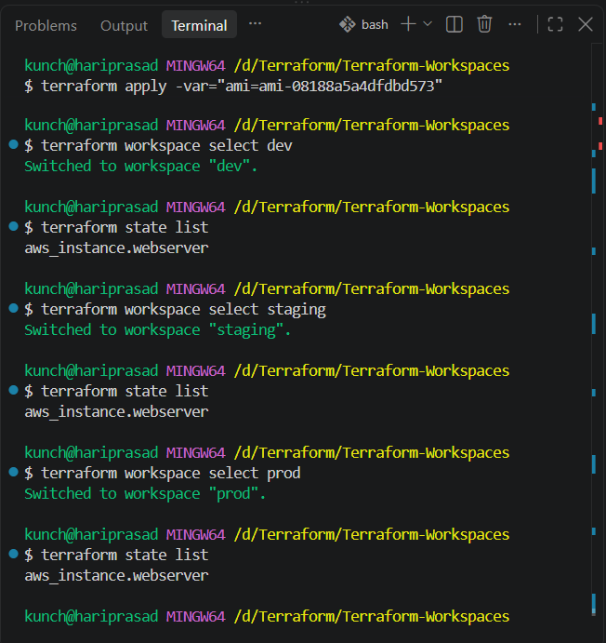

Step 16 — Demonstrate switching workspaces
Your document also specifically lists:
terraform workspace select workspacename
for switching workspaces.
For example:
terraform workspace select dev
Then:
terraform workspace show
Output:
dev
Switch:
terraform workspace select prod
Then:
terraform workspace show
Output:
Prod
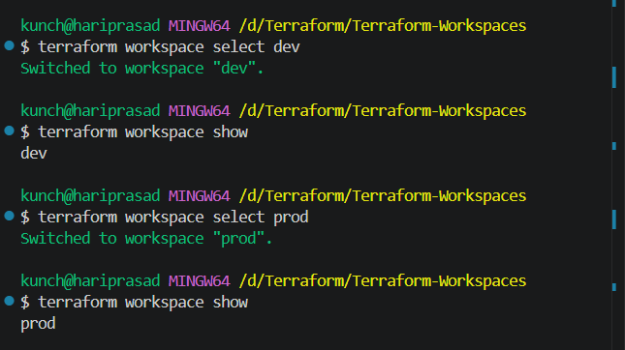

Step 17 — Check AWS
Go to:
AWS Console → EC2 → Instances
You should see three instances:
Workspace | EC2 Name
dev | terraform-dev
staging | terraform-staging
prod | terraform-prod
This demonstrates:
SAME CODE
│
┌──────────┼──────────┐
↓ ↓ ↓
dev staging prod
│ │ │
EC2 EC2 EC2
│ │ │
State-Dev State-Staging State-Prod

Step 18 — Cleanup
Once you've taken your screenshots/evidence, destroy each environment separately.
Dev
terraform workspace select dev
terraform destroy -var="ami=ami-08188a5a4dfdbd573"
Enter:
yes
Staging
terraform workspace select staging
terraform destroy -var="ami=ami-08188a5a4dfdbd573"
Enter:
yes
Prod
terraform workspace select prod
terraform destroy -var="ami=ami-08188a5a4dfdbd573"
Enter:
yes

Step 19 — Delete the workspaces
The document gives:
terraform workspace delete workspacename
as the workspace deletion command.
First switch to default:
terraform workspace select default
Then:
terraform workspace delete dev
terraform workspace delete staging
terraform workspace delete prod
Finally:
terraform workspace list
You should have:
* default
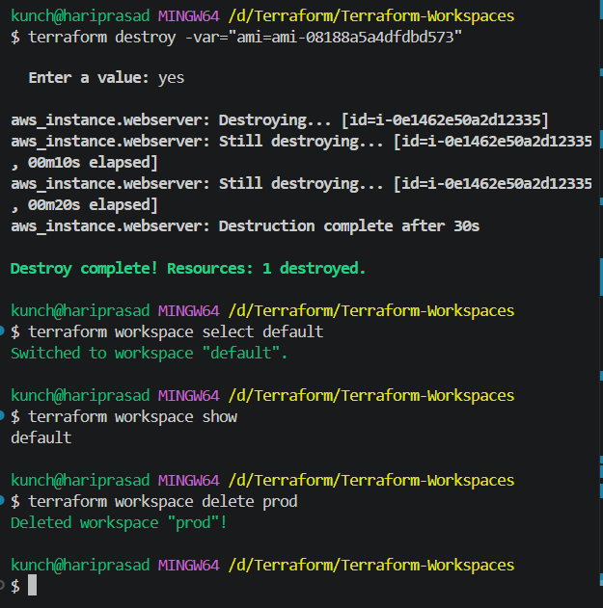

Task 3 — Provision EC2, S3 & VPC Using Terraform Modules
Objective
Using Terraform modules, we will provision:
VPC
├── Public Subnet
├── Internet Gateway
└── Route Table

EC2
└── Security Group

S3 Bucket
The important part is that VPC, EC2, and S3 will each be separate reusable modules.

Step 1 — Create the project folder
In VS Code, create a new folder:
Task-3-Terraform-Modules
Open this folder in VS Code.
Your initial structure should be:
Task-3-Terraform-Modules/

Step 2 — Create the module folders
Inside Task-3-Terraform-Modules, create:
modules
Inside modules, create these three folders:
modules/
├── vpc/
├── ec2/
└── s3/
Your structure should now be:
Task-3-Terraform-Modules/
│
└── modules/
├── vpc/
├── ec2/
└── s3/
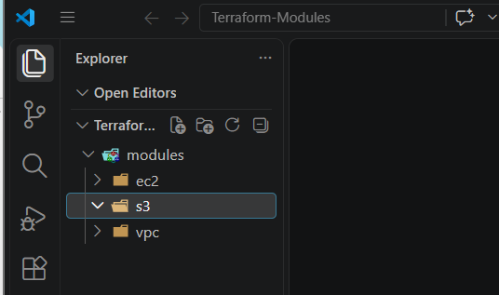

Step 3 — Create root Terraform files
In the main Task-3-Terraform-Modules folder, create:
main.tf
variables.tf
outputs.tf
terraform.tfvars
So the complete structure is:
Task-3-Terraform-Modules/
│
├── main.tf
├── variables.tf
├── outputs.tf
├── terraform.tfvars
│
└── modules/
├── vpc/
├── ec2/
└── s3/
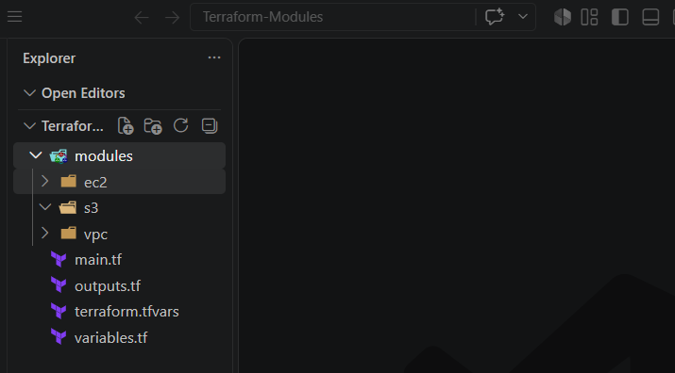

Step 4 — Create VPC module files
Inside:
modules/vpc/
create:
main.tf
variables.tf
outputs.tf
So:
modules/
└── vpc/
├── main.tf
├── variables.tf
└── outputs.tf
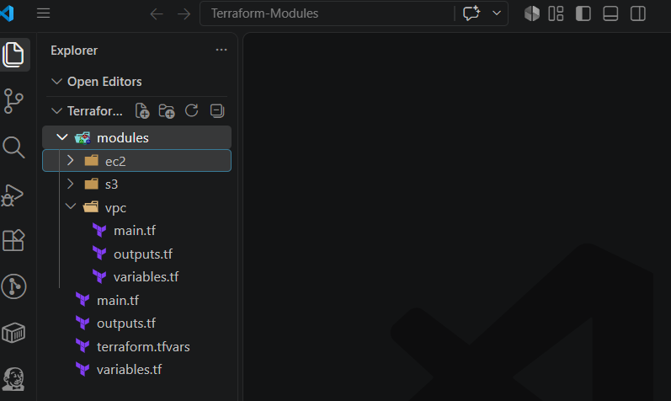

Step 5 — Create EC2 module files
Inside:
modules/ec2/
create:
main.tf
variables.tf
outputs.tf
Structure:
modules/
└── ec2/
├── main.tf
├── variables.tf
└── outputs.tf
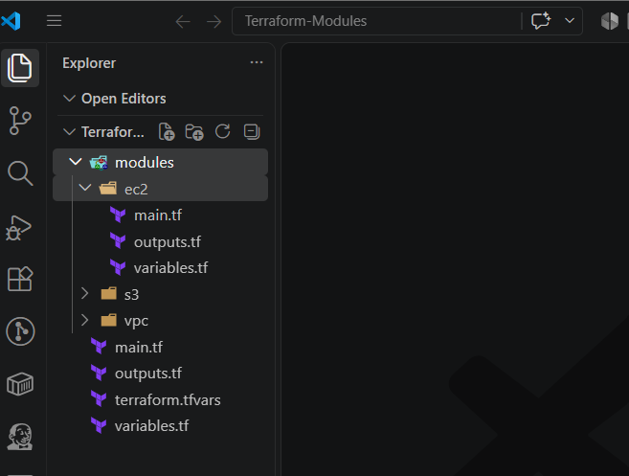

Step 6 — Create S3 module files
Inside:
modules/s3/
create:
main.tf
variables.tf
outputs.tf
Final structure:
Task-3-Terraform-Modules/
│
├── main.tf
├── variables.tf
├── outputs.tf
├── terraform.tfvars
│
└── modules/
│
├── vpc/
│ ├── main.tf
│ ├── variables.tf
│ └── outputs.tf
│
├── ec2/
│ ├── main.tf
│ ├── variables.tf
│ └── outputs.tf
│
└── s3/
├── main.tf
├── variables.tf
└── outputs.tf
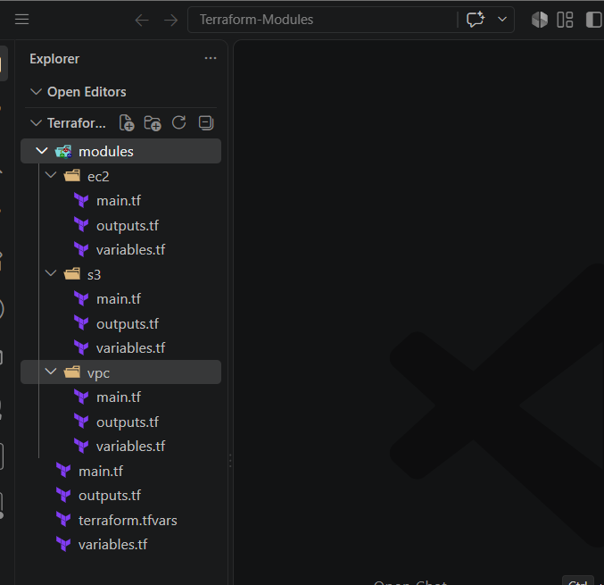

Step 7 — Understand what we're building
The root main.tf will call the three modules:
main.tf
│
┌────────────┼────────────┐
↓ ↓ ↓
VPC Module EC2 Module S3 Module
The EC2 module will receive information from the VPC module:
VPC Module
│
├── VPC ID
│
└── Subnet ID
│
↓
EC2 Module
This is the important module-to-module dependency we'll implement.

Step 8 — Before writing code
Run this in the VS Code terminal:
cd Task-3-Terraform-Modules
Then verify you're in the correct directory:
pwd
On Windows PowerShell you can also use:
Get-Location
You should see your Task-3-Terraform-Modules directory.
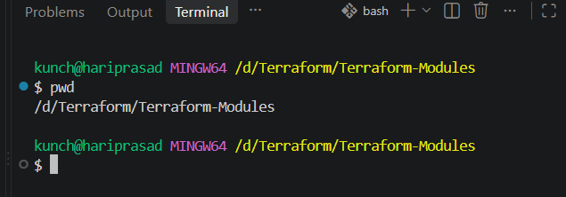

Next: Step 9 — Build the VPC Module
Let's do only the VPC module first.
Open:
modules/vpc/main.tf
Paste this:
resource "aws_vpc" "this" {
cidr_block = var.vpc_cidr
enable_dns_support = true
enable_dns_hostnames = true

tags = {
Name = var.vpc_name
}
}

resource "aws_subnet" "public" {
vpc_id = aws_vpc.this.id
cidr_block = var.public_subnet_cidr
availability_zone = var.availability_zone
map_public_ip_on_launch = true

tags = {
Name = "${var.vpc_name}-public-subnet"
}
}

resource "aws_internet_gateway" "this" {
vpc_id = aws_vpc.this.id

tags = {
Name = "${var.vpc_name}-igw"
}
}

resource "aws_route_table" "public" {
vpc_id = aws_vpc.this.id

route {
cidr_block = "0.0.0.0/0"
gateway_id = aws_internet_gateway.this.id
}

tags = {
Name = "${var.vpc_name}-public-rt"
}
}

resource "aws_route_table_association" "public" {
subnet_id = aws_subnet.public.id
route_table_id = aws_route_table.public.id
}
What this module creates
VPC: 10.0.0.0/16
│
└── Public Subnet: 10.0.1.0/24
│
└── Route Table
│
└── Internet Gateway

Step 10 — VPC variables
Open:
modules/vpc/variables.tf
Paste:
variable "vpc_cidr" {
type = string
}

variable "public_subnet_cidr" {
type = string
}

variable "availability_zone" {
type = string
}

variable "vpc_name" {
type = string
}

Step 11 — VPC outputs
Open:
modules/vpc/outputs.tf
Paste:
output "vpc_id" {
value = aws_vpc.this.id
}

output "public_subnet_id" {
value = aws_subnet.public.id
}
These outputs are important because later the EC2 module will use the VPC ID and subnet ID.

Step 12 — Build the EC2 Module
Now we'll create the EC2 module that receives:
- AMI ID
- Instance type
- VPC ID
- Subnet ID
- Instance name
It will create:
EC2
│
└── Security Group
├── SSH : 22
└── HTTP : 80

12.1 — modules/ec2/main.tf
Open:
modules/ec2/main.tf
Paste:
resource "aws_security_group" "this" {
name = "${var.instance_name}-sg"
vpc_id = var.vpc_id

ingress {
description = "SSH"
from_port = 22
to_port = 22
protocol = "tcp"
cidr_blocks = ["0.0.0.0/0"]
}

ingress {
description = "HTTP"
from_port = 80
to_port = 80
protocol = "tcp"
cidr_blocks = ["0.0.0.0/0"]
}

egress {
from_port = 0
to_port = 0
protocol = "-1"
cidr_blocks = ["0.0.0.0/0"]
}

tags = {
Name = "${var.instance_name}-sg"
}
}

resource "aws_instance" "this" {
ami = var.ami_id
instance_type = var.instance_type
subnet_id = var.subnet_id
vpc_security_group_ids = [aws_security_group.this.id]

tags = {
Name = var.instance_name
}
}

12.2 — modules/ec2/variables.tf
Open:
modules/ec2/variables.tf
Paste:
variable "ami_id" {
type = string
}

variable "instance_type" {
type = string
}

variable "subnet_id" {
type = string
}

variable "vpc_id" {
type = string
}

variable "instance_name" {
type = string
}

12.3 — modules/ec2/outputs.tf
Open:
modules/ec2/outputs.tf
Paste:
output "instance_id" {
value = aws_instance.this.id
}

output "public_ip" {
value = aws_instance.this.public_ip
}

output "security_group_id" {
value = aws_security_group.this.id
}

🔑 Understand the module connection
Later, in the root main.tf, we'll connect EC2 to VPC like this:
module "ec2" {
source = "./modules/ec2"

subnet_id = module.vpc.public_subnet_id
vpc_id = module.vpc.vpc_id
}
So:
VPC MODULE
│
┌──────┴──────┐
│ │
vpc_id subnet_id
│ │
└──────┬──────┘
↓
EC2 MODULE
That's the important reason we're using modules rather than putting everything in one main.tf.
Step 13 — Build the S3 Module
Now we'll create the third and final module:
modules/s3/
├── main.tf
├── variables.tf
└── outputs.tf
This module will create an S3 bucket.

13.1 — modules/s3/main.tf
Open:
modules/s3/main.tf
Paste:
resource "aws_s3_bucket" "this" {
bucket = var.bucket_name

tags = {
Name = var.bucket_name
}
}

13.2 — modules/s3/variables.tf
Open:
modules/s3/variables.tf
Paste:
variable "bucket_name" {
type = string
}

13.3 — modules/s3/outputs.tf
Open:
modules/s3/outputs.tf
Paste:
output "bucket_name" {
value = aws_s3_bucket.this.bucket
}

output "bucket_arn" {
value = aws_s3_bucket.this.arn
}

Step 14 — Check Your Structure
At this point you should have:
Terraform-Modules/
│
├── main.tf
├── outputs.tf
├── terraform.tfvars
├── variables.tf
│
└── modules/
│
├── ec2/
│ ├── main.tf
│ ├── outputs.tf
│ └── variables.tf
│
├── s3/
│ ├── main.tf
│ ├── outputs.tf
│ └── variables.tf
│
└── vpc/
├── main.tf
├── outputs.tf
└── variables.tf
So far:
✅ VPC Module
✅ EC2 Module
✅ S3 Module
Now we need to connect all three modules from the root module.
Step 15 — Configure Root main.tf
Open the root-level file:
Terraform-Modules/main.tf
⚠️ Make sure you're opening:
main.tf
directly under Terraform-Modules, not:
modules/vpc/main.tf
modules/ec2/main.tf
modules/s3/main.tf
Delete anything currently inside the root main.tf and paste:
terraform {
required_providers {
aws = {
source = "hashicorp/aws"
version = "~> 6.0"
}
}
}

provider "aws" {
region = var.aws_region
}

module "vpc" {
source = "./modules/vpc"

vpc_cidr = var.vpc_cidr
public_subnet_cidr = var.public_subnet_cidr
availability_zone = var.availability_zone
vpc_name = var.vpc_name
}

module "ec2" {
source = "./modules/ec2"

ami_id = var.ami_id
instance_type = var.instance_type
subnet_id = module.vpc.public_subnet_id
vpc_id = module.vpc.vpc_id
instance_name = var.instance_name
}

module "s3" {
source = "./modules/s3"

bucket_name = var.bucket_name
}
Understand this part carefully 👇
We are calling our three modules:
module "vpc" {
source = "./modules/vpc"
}
module "ec2" {
source = "./modules/ec2"
}
module "s3" {
source = "./modules/s3"
}
And this is the important connection:
subnet_id = module.vpc.public_subnet_id
vpc_id = module.vpc.vpc_id
The VPC module creates the VPC/subnet, then its outputs are passed to the EC2 module.

Step 16 — Root variables.tf
Open:
Terraform-Modules/variables.tf
Delete existing content and paste:
variable "aws_region" {
type = string
}

variable "vpc_cidr" {
type = string
}

variable "public_subnet_cidr" {
type = string
}

variable "availability_zone" {
type = string
}

variable "vpc_name" {
type = string
}

variable "ami_id" {
type = string
}

variable "instance_type" {
type = string
}

variable "instance_name" {
type = string
}

variable "bucket_name" {
type = string
}

Step 17 — Root terraform.tfvars
Open:
Terraform-Modules/terraform.tfvars
Paste:
aws_region = "ap-south-1"

vpc_cidr = "10.0.0.0/16"

public_subnet_cidr = "10.0.1.0/24"

availability_zone = "ap-south-1a"

vpc_name = "terraform-modules-vpc"

ami_id = "YOUR_AMI_ID"

instance_type = "t3.micro"

instance_name = "terraform-modules-ec2"

bucket_name = "YOUR-UNIQUE-BUCKET-NAME"
You need to replace these two values:
YOUR_AMI_ID
with your valid Mumbai AMI ID.
And:
YOUR-UNIQUE-BUCKET-NAME
with a globally unique S3 bucket name.
For example:
ami_id = "ami-xxxxxxxxxxxxxxxxx"

bucket_name = "venu-terraform-modules-2026-xxxxx"
Don't copy my example AMI ID. Use the AMI you've been using for your Mumbai EC2 labs.

Step 18 — Root outputs.tf
Open:
Terraform-Modules/outputs.tf
Paste:
output "vpc_id" {
value = module.vpc.vpc_id
}

output "public_subnet_id" {
value = module.vpc.public_subnet_id
}

output "ec2_instance_id" {
value = module.ec2.instance_id
}

output "ec2_public_ip" {
value = module.ec2.public_ip
}

output "security_group_id" {
value = module.ec2.security_group_id
}

output "s3_bucket_name" {
value = module.s3.bucket_name
}

output "s3_bucket_arn" {
value = module.s3.bucket_arn
}

Step 19 — Final structure
Your project should now look exactly like this:
Terraform-Modules/
│
├── main.tf
├── variables.tf
├── terraform.tfvars
├── outputs.tf
│
└── modules/
│
├── vpc/
│ ├── main.tf
│ ├── variables.tf
│ └── outputs.tf
│
├── ec2/
│ ├── main.tf
│ ├── variables.tf
│ └── outputs.tf
│
└── s3/
├── main.tf
├── variables.tf
└── outputs.tf

Step 20 — Don't run apply yet
Before creating AWS resources, we will first run:
terraform init
then:
terraform validate
then:
terraform plan
This lets us catch any mistakes before creating the VPC, EC2, and S3 bucket.

Step 21 — Open the VS Code Terminal
Make sure your terminal is inside the project folder:
Terraform-Modules
Run:
pwd
You should see something ending with:
Terraform-Modules
If you're using PowerShell:
Get-Location


Step 22 — Initialize Terraform
Run:
terraform init
Terraform should:
- Initialize the AWS provider
- Detect the three local modules
- Download the provider
- Create the .terraform directory
At the end, you should see something similar to:
Terraform has been successfully initialized!
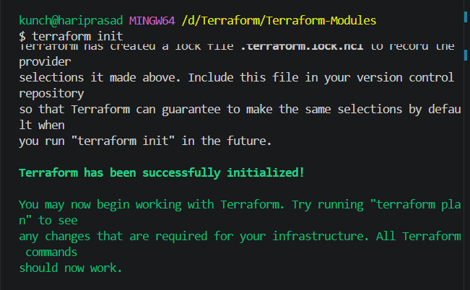

Step 23 — Validate the configuration
Run:
terraform validate
Expected:
Success! The configuration is valid.
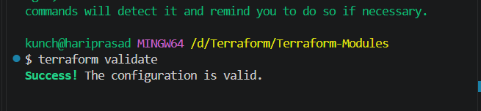

Step 24 — Format the Terraform files
Run:
terraform fmt -recursive
This formats both the root files and all module files.
You can also run:
terraform fmt -check -recursive
If everything is formatted correctly, it won't report files needing changes.

Step 25 — Create the Terraform Plan
Now run:
terraform plan
Terraform should show resources to be created.
You should expect approximately 7 resources:
aws_vpc
aws_subnet
aws_internet_gateway
aws_route_table
aws_route_table_association
aws_security_group
aws_instance
aws_s3_bucket
Actually, that's 8 resources. 👍
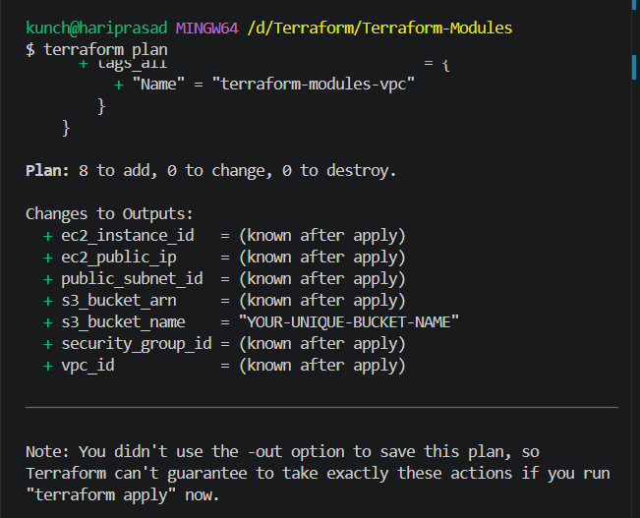
The dependency flow will be:
VPC MODULE
│
┌──────────┴──────────┐
↓ ↓
VPC Subnet
│
↓
EC2 MODULE
├── Security Group
└── EC2

S3 MODULE
│
↓
S3 Bucket

Step 26 — Verify Terraform state
Run:
terraform state list
You should see resources such as:
module.vpc.aws_vpc.this
module.vpc.aws_subnet.public
module.vpc.aws_internet_gateway.this
module.vpc.aws_route_table.public
module.vpc.aws_route_table_association.public
module.ec2.aws_security_group.this
module.ec2.aws_instance.this
module.s3.aws_s3_bucket.this
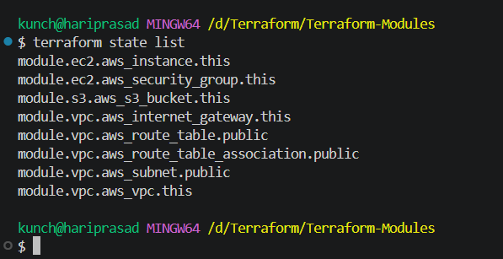

Task 4 — EC2 for Dev, Staging & Prod Using Terraform Workspaces
Objective
We will use one Terraform configuration and create three separate workspaces:
Terraform Workspaces
│
├── dev
│ └── EC2
│
├── staging
│ └── EC2
│
└── prod
└── EC2
Each workspace gets its own Terraform state.

Step 1 — Create a NEW folder
Do not use Terraform-Modules.
Create a new folder:
Terraform-Workspaces
Recommended location:
D:\Terraform\Terraform-Workspaces
Open this folder in VS Code.

Step 2 — Create the Terraform files
Inside Terraform-Workspaces, create only these 3 files:
Terraform-Workspaces/
│
├── main.tf
├── variables.tf
└── outputs.tf
That's it for now.
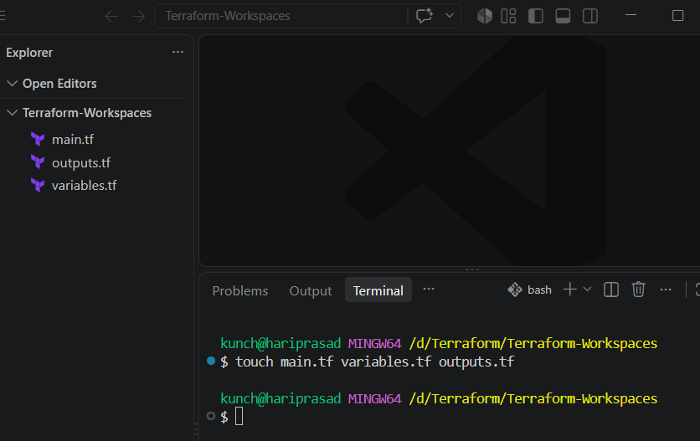

Step 3 — Create main.tf
Open:
main.tf
Paste:
terraform {
required_providers {
aws = {
source = "hashicorp/aws"
version = "~> 6.0"
}
}
}

provider "aws" {
region = var.aws_region
}

locals {
environment = terraform.workspace

instance_name = "terraform-${terraform.workspace}"

instance_type = (
terraform.workspace == "prod" ? "t3.small" :
terraform.workspace == "staging" ? "t3.micro" :
"t3.micro"
)
}

resource "aws_instance" "app" {
ami = var.ami_id
instance_type = local.instance_type

tags = {
Name = local.instance_name
Environment = local.environment
}
}
Important concept
This line:
environment = terraform.workspace
automatically gets the current workspace.
For example:
dev → terraform.workspace = "dev"

staging → terraform.workspace = "staging"

prod → terraform.workspace = "prod"
And this:
instance_type = (
terraform.workspace == "prod" ? "t3.small" :
terraform.workspace == "staging" ? "t3.micro" :
"t3.micro"
)
means:
dev → t3.micro
staging → t3.micro
prod → t3.small

Step 4 — Create variables.tf
Open:
variables.tf
Paste:
variable "aws_region" {
type = string
default = "ap-south-1"
}

variable "ami_id" {
type = string
}

Step 5 — Create outputs.tf
Open:
outputs.tf
Paste:
output "workspace" {
value = terraform.workspace
}

output "instance_id" {
value = aws_instance.app.id
}

output "instance_type" {
value = aws_instance.app.instance_type
}

output "public_ip" {
value = aws_instance.app.public_ip
}

output "instance_name" {
value = aws_instance.app.tags["Name"]
}

Step 6 — Your structure should look like this
Terraform-Workspaces/
│
├── main.tf
├── variables.tf
└── outputs.tf
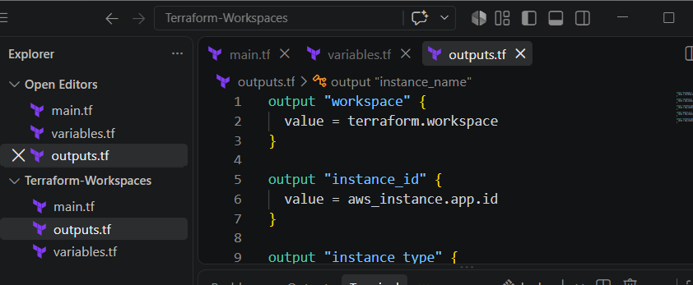
Step 7 — Initialize Terraform
Make sure your VS Code terminal is inside:
D:\Terraform\Terraform-Workspaces
Run:
terraform init
You should get:
Terraform has been successfully initialized!
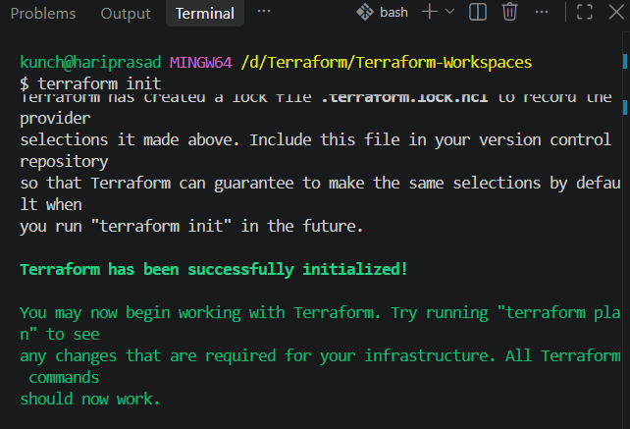

Step 8 — Validate the configuration
Run:
terraform validate
Expected:
Success! The configuration is valid.
Then format:
terraform fmt
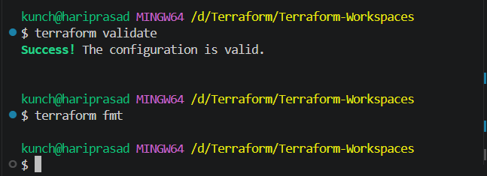

Step 9 — Check the current workspace
Run:
terraform workspace show
Initially you'll see:
default
Now list all workspaces:
terraform workspace list
Expected:
* default
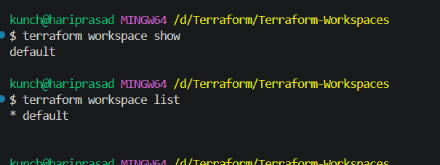

Step 10 — Create the Dev workspace
Run:
terraform workspace new dev
You should see something similar to:
Created and switched to workspace "dev"!
Verify:
terraform workspace show
Expected:
dev
And:
terraform workspace list
should show:
default
* dev
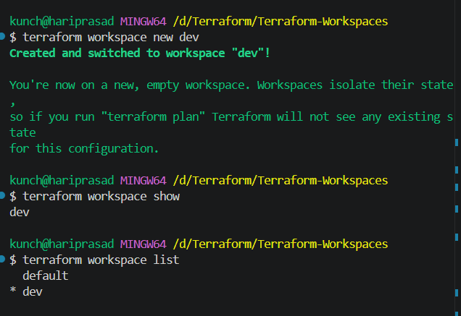

Step 11 — Deploy the Dev EC2
Use the same AMI ID you used successfully in Task 3.
Run:
terraform plan -var="ami_id=YOUR_AMI_ID"
For example:
terraform plan -var="ami_id=ami-xxxxxxxxxxxxxxxxx"
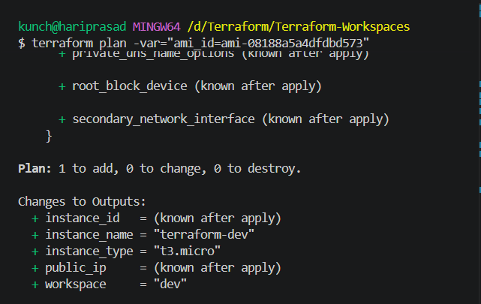
Check that the plan shows:
instance_type = t3.micro
and the tags should contain:
Name = terraform-dev
Environment = dev
If the plan is successful, run:
terraform apply -var="ami_id=YOUR_AMI_ID"
Enter:
Yes

Step 12 — Verify Dev
After apply completes:
terraform output
You should see something like:
instance_id = "i-xxxxxxxxxxxxxxxxx"
instance_name = "terraform-dev"
instance_type = "t3.micro"
public_ip = "xx.xx.xx.xx"
workspace = "dev"
🎯 This confirms that the Dev workspace created the Dev EC2.
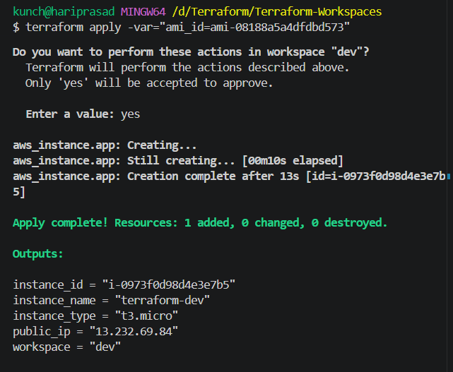
Step 13 — Create Staging Workspace
First verify you're currently in dev:
terraform workspace show
Expected:
dev
Now create the Staging workspace:
terraform workspace new staging
You should get:
Created and switched to workspace "staging"!
Verify:
terraform workspace show
Expected:
staging
Then run:
terraform workspace list
You should see:
default
dev
* staging
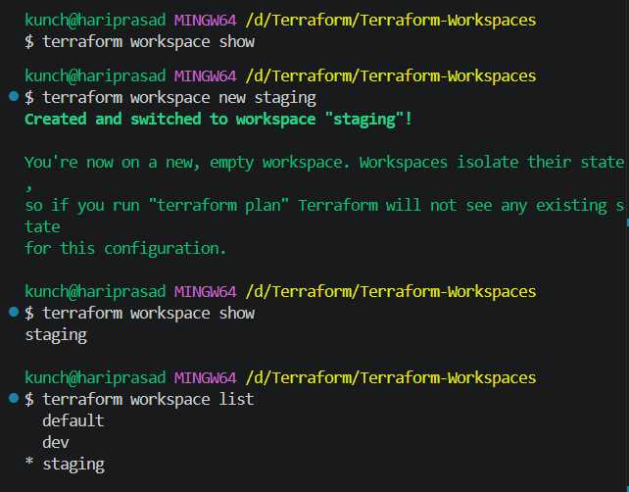

Step 14 — Plan Staging
Use the same AMI:
terraform plan -var="ami_id=ami-08188a5a4dfdbd573"
Because we're in the staging workspace, Terraform should plan:
1 to add
0 to change
0 to destroy
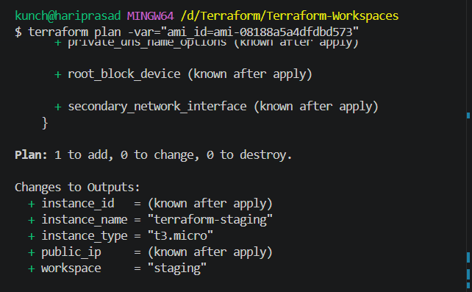
And the EC2 should be:
Name = terraform-staging
Environment = staging
Instance = t3.micro
Important
The existing Dev EC2 will not be destroyed.
That's the whole point of workspaces:
dev state → Dev EC2
staging state → Staging EC2
Run the terraform plan first. If it shows Plan: 1 to add, proceed with:
terraform apply -var="ami_id=ami-08188a5a4dfdbd573"
Enter:
Yes
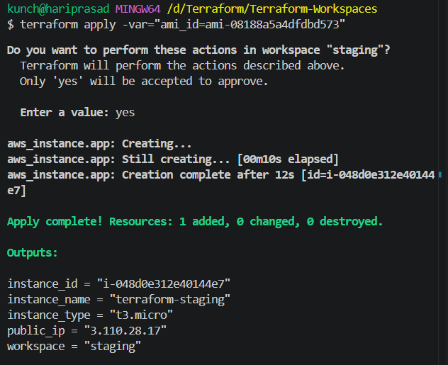
Step 15 — Create Production Workspace
First check your current workspace:
terraform workspace show
It should say:
staging
Now create Production:
terraform workspace new prod
Expected:
Created and switched to workspace "prod"!
Verify:
terraform workspace show
Expected:
prod
Then:
terraform workspace list
You should see:
default
dev
* prod
staging
The * indicates the currently selected workspace.
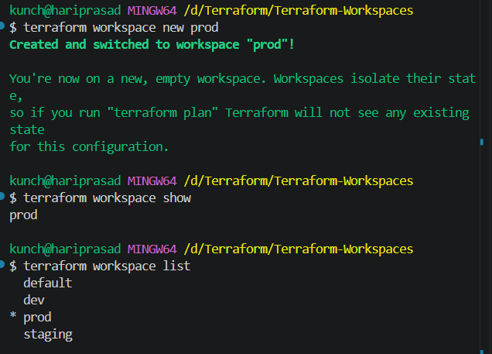

Step 16 — Plan Production
Run:
terraform plan -var="ami_id=ami-08188a5a4dfdbd573"
Because our main.tf contains:
terraform.workspace == "prod" ? "t3.small" :
Production should use:
Instance type = t3.small
and:
Name = terraform-prod
Environment = prod
You should see:
Plan: 1 to add, 0 to change, 0 to destroy.
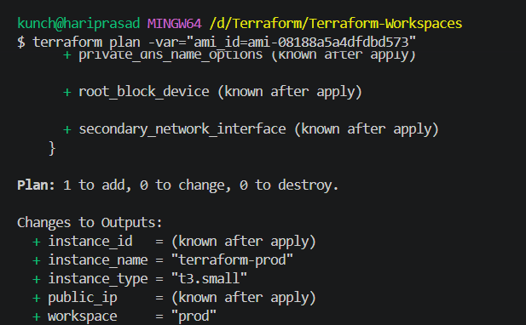
Step 17 — Apply Production
Run:
terraform apply -var="ami_id=ami-08188a5a4dfdbd573"
Terraform should ask:
Do you want to perform these actions in workspace "prod"?
Enter:
yes
Wait for:
Apply complete! Resources: 1 added, 0 changed, 0 destroyed.
Then run:
terraform output
You should get approximately:
instance_id = "i-xxxxxxxxxxxxxxxxx"
instance_name = "terraform-prod"
instance_type = "t3.small"
public_ip = "xx.xx.xx.xx"
workspace = "prod"
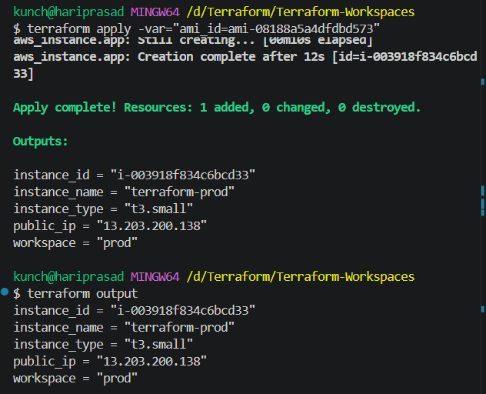

Step 18 — Verify all 3 workspaces
Now let's prove the main purpose of this task.
Dev
terraform workspace select dev
terraform output
Expected:
workspace = "dev"
instance_name = "terraform-dev"
instance_type = "t3.micro"
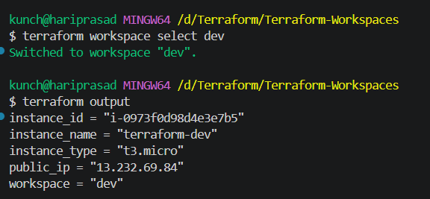
Staging
terraform workspace select staging
terraform output
Expected:
workspace = "staging"
instance_name = "terraform-staging"
instance_type = "t3.micro"
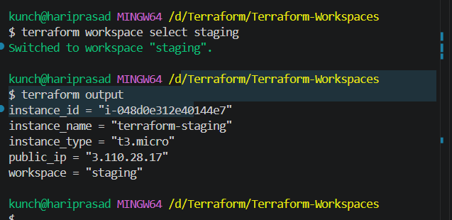
Prod
terraform workspace select prod
terraform output
Expected:
workspace = "prod"
instance_name = "terraform-prod"
instance_type = "t3.small"
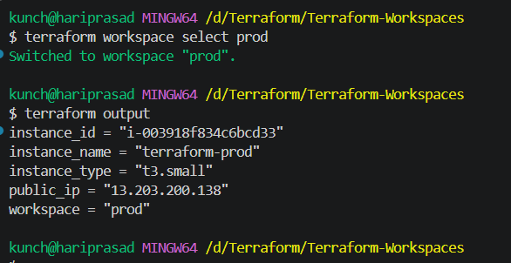

Final workspace view
Run:
terraform workspace list
You should have:
default
dev
staging
* prod
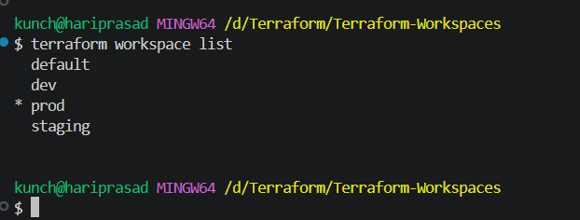
And AWS should contain:
┌──────────┬───────────────────┬───────────────┐
│ Workspace│ EC2 Name │ Instance Type │
├──────────┼───────────────────┼───────────────┤
│ dev │ terraform-dev │ t3.micro │
│ staging │ terraform-staging │ t3.micro │
│ prod │ terraform-prod │ t3.small │
└──────────┴───────────────────┴───────────────┘

